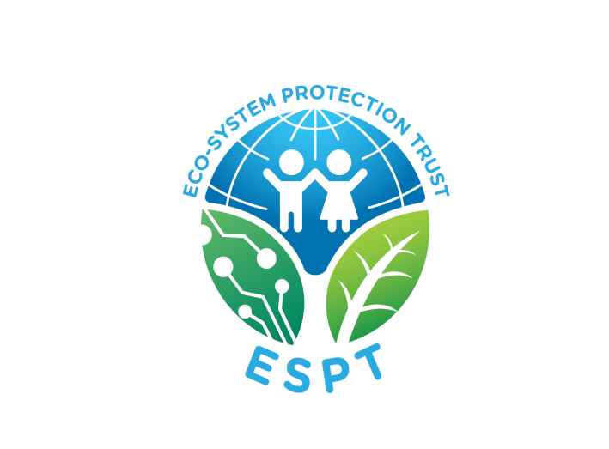**Our Vision:**

“A self-reliant society existing in a sustainable eco-system valuing respect and dignity of all”

**Our Mission:**

“To promote environmental and social well-being by building human potential and spreading empathy among most vulnerable communities”